Recall: The derivative $f'(a)$ can be interpreted as the slope of line tangent to $f(x)$ at $x=a$

Goal: Find an equation of the line tangent to $y=f(x)$ at $x=a$

Solution:

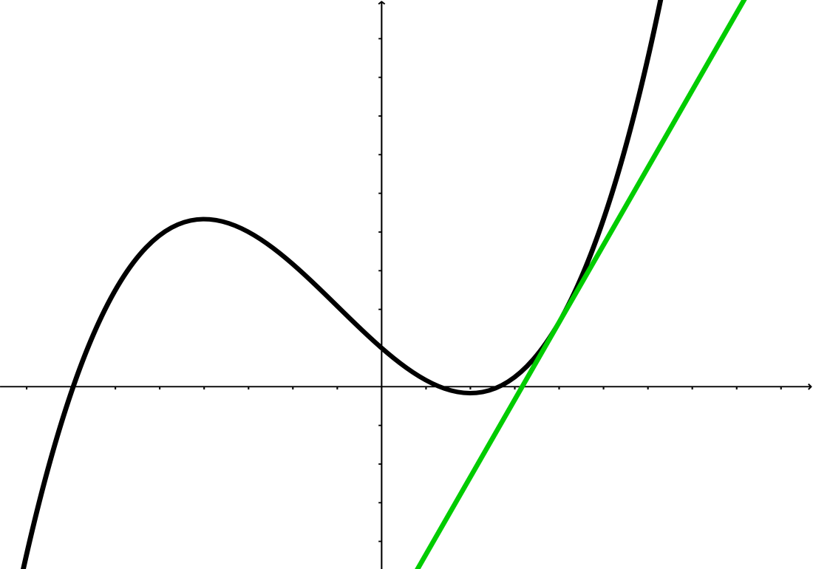

An equation of the line tangent to $y=f(x)$ at $x=a$ is:

$y=$

Example: Suppose that we run a car dealership and our cost to sell 15 cars is $200,000 and the derivative $C^{'}\left(15\right)=10000$:

$C\left(15\right)=$

$C^{'}\left(15\right)=$

Estimate the cost to sell 17 cars.

Recall: We studied the idea of relative change by looking at comparing the change in populations to Williamsburg, MA vs. NYC.

$$Relative Change=$$

Just like with change, it is sometimes important to compare the rate of change to the original amount.

$$Relative rate of Change=$$

Example: Find the Relative Rate of Change for

$$y=2^{x} ; at x=1$$