Recall: The derivative of the function $f\left(x\right)$ at $x=a$ is:

$$f^{'}\left(a\right)=\lim_{∆x→o}{\frac{f\left(a+∆x\right)-f(a)}{∆x}}$$

For each input value, $x$, we can compute an output value which is $f'(x)$ using the definition above.

Recall: Definition: A function is a mathematical rule which assigns to each input value an output value.

The derivative $f'(x)$ is a function.

$f^{'}\left(x\right)=$

Example: Find the derivative of the function $f\left(x\right)=x^{2}$

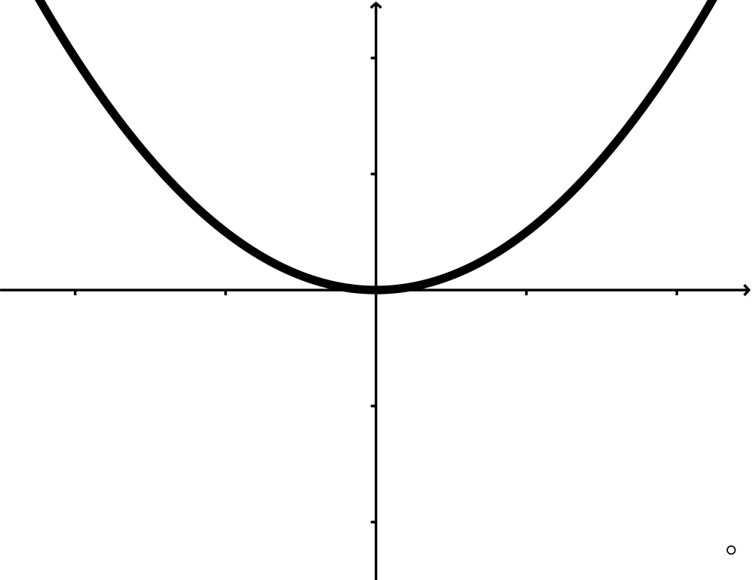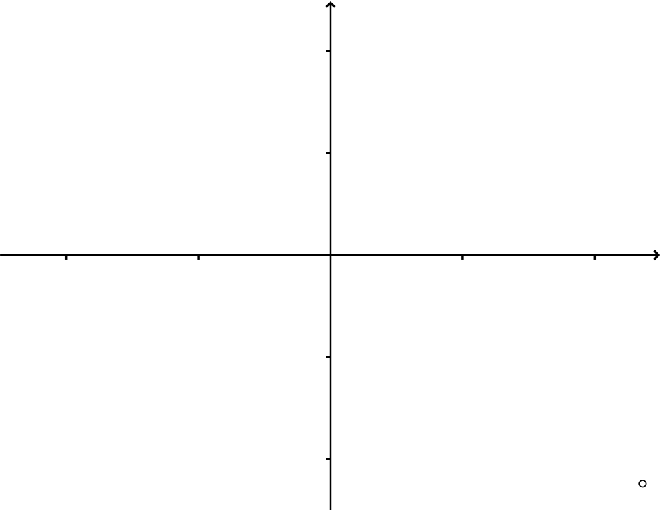

$$f '\left(x\right)=2x$$

$$f\left(x\right)=x^{2}$$

Old: We say that a function, $y=f\left(x\right)$, is increasing if the a $ve. rate of change \frac{∆y}{∆x}>0$.

We say that a function, $y=f\left(x\right)$, is decreasing if the ave. rate of change $\frac{∆y}{∆x}<0$.

New:

$$f\left(x\right)$$

$$f '\left(x\right)$$

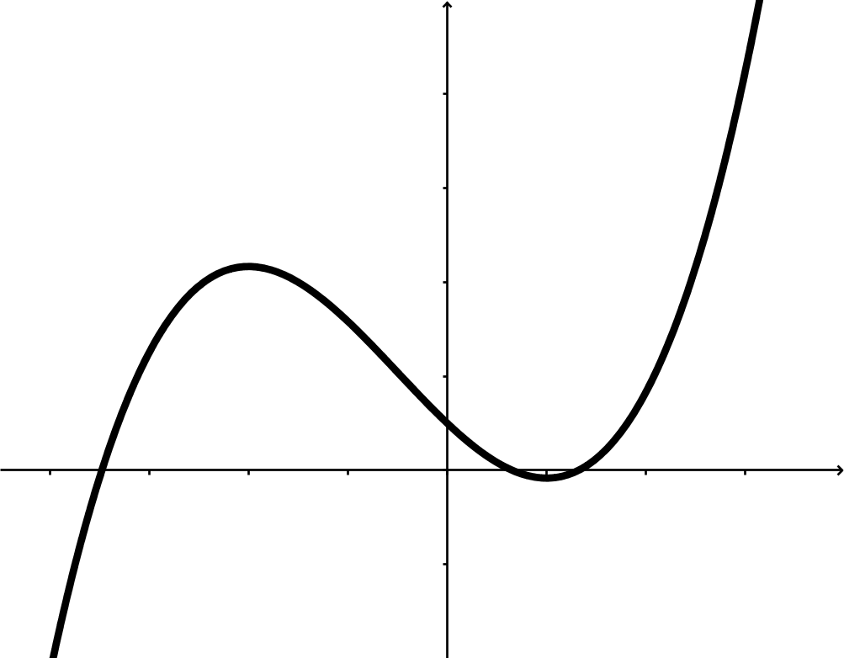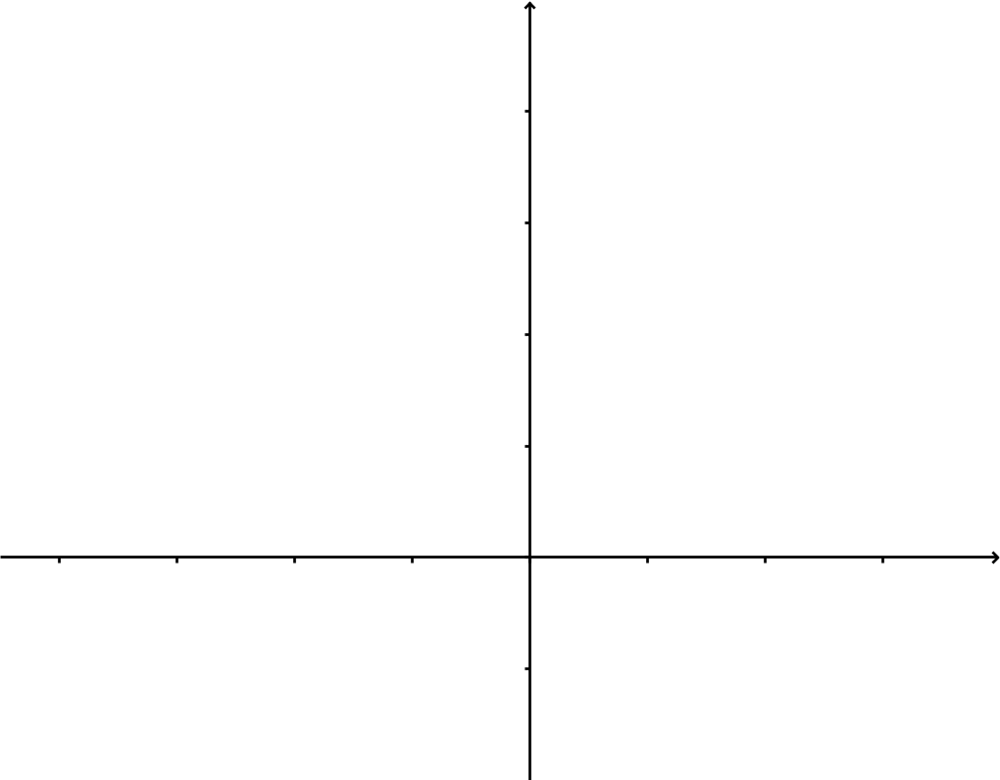

Recall: The derivative, $f'(x)$, can be interpreted as the (instantaneous) rate of change of $f(x)$.

Just like our original rate of change (slope);

The units of $f^{'}\left(x\right)=$

Notation: $f^{'}\left(x\right)=$

Example 1: For the cost function $C(q)$

$C\left(q\right)=$ Cost to produce quantity $q$ items (units in dollars)

$q=$ quantity of items produce (units in items)

The units of $C^{'}\left(q\right)=$

Example 2: For the position function $s\left(t\right)$

$s\left(t\right)=$ position at time $t$ (units in feet)

$t=$ seconds

The units of $s^{'}\left(t\right)=$