Recall: For a linear function (or line), the rate of change is called the slope and it is always the same between any two points.

For any function, y=f(x), the average rate of change between two points (x1,y1) and (x2,y2) is calculated the same as slope:

Average rate of change

between x = x1 and x=x2

=

Note: The units of rate of change, average rate of change, and slope are all the same and are

Example 1 (Physics): Suppose that the height of a calculator thrown into the air is given by *s(t)*. The values of the height *s(t)* are given by the table:

|  |  |  |  |  |  |
| --- | --- | --- | --- | --- | --- |
| t (sec) | 0 | 1 | 2 | 3 | 4 |
| s(t) (ft) | 4 | 63 | 90 | 85 | 48 |

Find the average rate of change of position with respect to time, which is called the average velocity, on each interval.

Average velocity between =

t = 0 and t =1

Average velocity between =

t = 1 and t =2

Average velocity between =

t = 2 and t =3

Average velocity between =

t = 3 and t =4

Example 2: Find the average rate of change of $y=f\left(x\right)=x^{2}$ on the three intervals:

* (x = -1 to x=0)
* (*x = 0* to *x = 1*)
* (*x = 1* to *x = 2)*

Average rate of change between x = -1and x=0

Average rate of change between x = -1and x=0

Average rate of change between x = -1and x=0

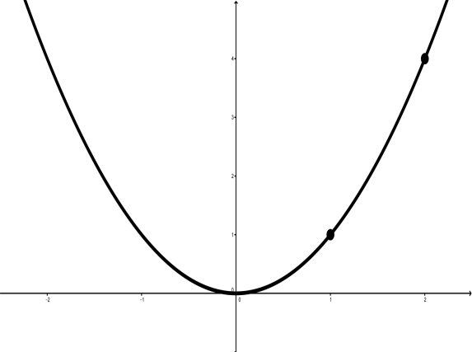

Example 1 (Physics): Suppose that the height of a calculator thrown into the air is given by *s(t)*. The values of the height *s(t)* are given by the table:

|  |  |  |  |  |  |
| --- | --- | --- | --- | --- | --- |
| t (sec) | 0 | 1 | 2 | 3 | 4 |
| s(t) (ft) | 4 | 63 | 90 | 85 | 48 |

Approximate the velocity at t=1

Approximation 1:

$v(1)≈$

Approximation 2:

$v(1)≈$

Approximation 3:

$v(1)≈$

In general, the best and quickest way to approximate the instantaneous velocity is

|  |  |  |  |  |  |
| --- | --- | --- | --- | --- | --- |
| t (sec) | 0 | 1 | 2 | 3 | 4 |
| s(t) (ft) | 4 | 63 | 90 | 85 | 48 |
| v(t) |  |  |  |  |  |

|  |  |  |
| --- | --- | --- |
| t (sec) | 0 | 0.5 |
| s(t) | 4 | 37.5 |

|  |  |  |
| --- | --- | --- |
| t (sec) | 0 | 0.1 |
| s(t) | 4 | 11.34 |

|  |  |  |
| --- | --- | --- |
| t (sec) | 0 | 0.01 |
| s(t) | 4 | 4.7484 |

|  |  |  |
| --- | --- | --- |
| t (sec) | 0 | 0.001 |
| s(t) | 4 | 4.074984 |

|  |  |  |
| --- | --- | --- |
| t (sec) | 0 | 0.0001 |
| s(t) | 4 | 4.00749984 |

|  |  |
| --- | --- |
|  | **Approx.**  **of $v(0)$** |
| 1 | 59 |
| .5 | 67 |
| .1 | 73.4 |
| .01 | 74.84 |
| .001 | 74.984 |
| .0001 | 74.9984 |
| .00001 | 74.99984 |

$$v(0)=$$

$v(0)≈$

As $∆t$ goes to zero

$∆t→0$

$$t=a$$

$$v(a)=\lim_{∆t→o}{\frac{s\left(a+∆t\right)-s(a)}{∆t}}$$

$v\left(0\right)=$

$s\left(t\right)=position$; $v\left(t\right)=velocity$

$v\left(t\right)=$ (instantaneous) rate of change of position

$$t=a$$

$$v(a)=\lim_{∆t→o}{\frac{s\left(a+∆t\right)-s(a)}{∆t}}$$

In general: The instantaneous rate of change of $f(x)$ at $x=a$ is given by:

This is called the derivative of $f(x)$ at $x=a$, and is written as $f'(a)$.

$f^{'}\left(a\right)=$

|  |  |
| --- | --- |
| $$∆x$$ | **Approx. $f'(1)$** |
|  |  |
|  |  |
|  |  |
|  |  |
|  |  |

Example: $f\left(x\right)=x^{2}$; find $f'(1)$

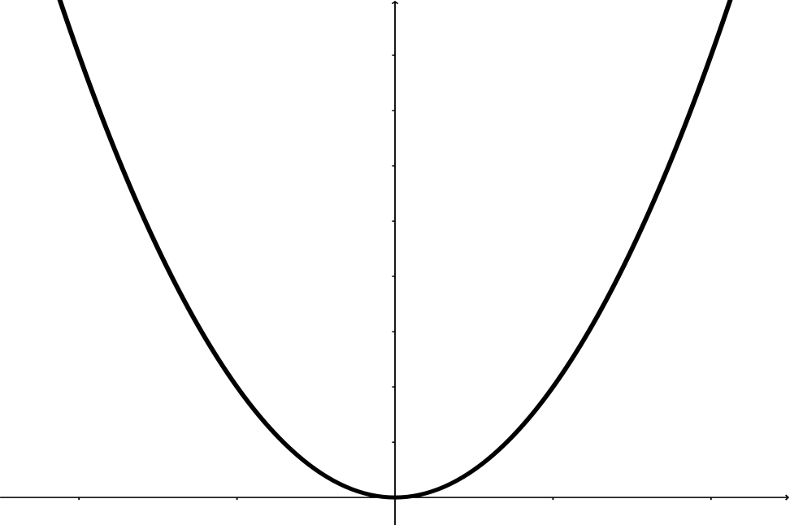

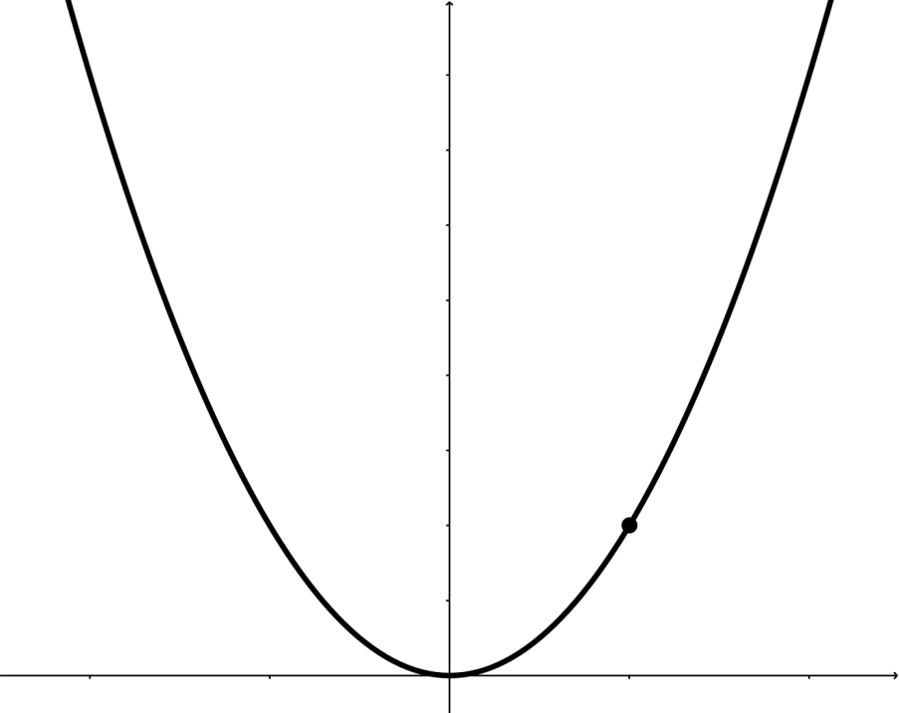

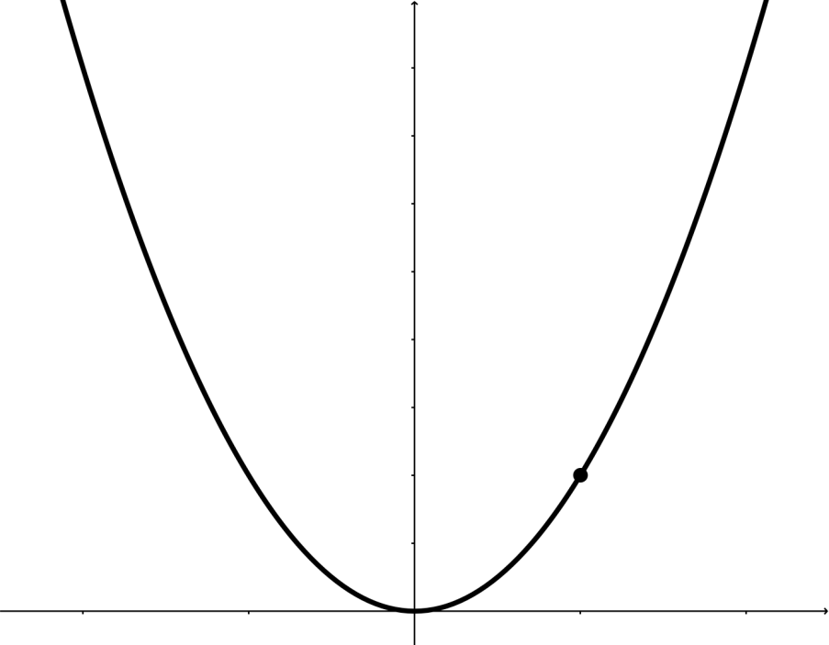

The derivative $f'(a)$ is:



Recall: $f^{'}\left(x\right)= \lim_{∆x→0}{\frac{f\left(x+∆x\right)-f\left(x\right)}{∆x}}$

Example: $f\left(x\right)=2^{x}$

Find $f'(1) =\lim_{∆x→0}{\frac{f\left(1+∆x\right)-f\left(1\right)}{∆x}}$

|  |  |
| --- | --- |
| $$∆x$$ | **Approx.**  **of $f'(1)$** |
|  |  |
|  |  |
|  |  |
|  |  |
|  |  |
|  |  |
|  |  |
| $$f'(1)≈$$ |  |

Recall: The derivative of the function $f\left(x\right)$ at $x=a$ is:

$$f^{'}\left(a\right)=\lim_{∆x→o}{\frac{f\left(a+∆x\right)-f(a)}{∆x}}$$

The derivative $f'(a)$ can be interpreted as:

* the rate of change of $f\left(x\right)$ at $x=a$
* the slope of line tangent to $f(x)$ at $x=a$
* the slope of curve at $x=a$

Example: Find the equation of the line tangent to the curve $y=x^{2}$ at $x=1$.

Slope:

Point:

