Visualization of Multiplication

$3⋅5=15$

Visualization:

Conclusion: We can visualize multiplication of $a∙b$ as a rectangle of height $a$ and width $b$.

Example: If we travel at a velocity of $10 ft/sec$ for 3 seconds, how far did we travel?

Solution:

$$Distance=velocity ∙time$$

Example: Velocities (in ft/sec) of a runner starting a race are:

|  |  |  |  |  |
| --- | --- | --- | --- | --- |
| $t$**(sec)** | $$0$$ | $$2$$ | $$4$$ | $$6$$ |
| $v\left(t\right)$ (ft/s) | $$0$$ | $$8$$ | $$14$$ | $$18$$ |

How far did the runner travel from $t=0$ to $t=2$?

Overestimate:

Underestimate:

How far did the runner travel from $t=2$ to $t=4$?

Overestimate:

Underestimate:

How far did the runner travel from $t=4$ to $t=6$?

Overestimate:

Underestimate:

How far did the runner travel from $t=0$ to $t=6$?

Overestimate:

Underestimate:

How do we get a better estimate?

Example: Velocities (in ft/sec) of a runner starting a race are:

|  |  |  |  |  |  |  |  |
| --- | --- | --- | --- | --- | --- | --- | --- |
| $t$**(sec)** | $$0$$ | $$1$$ | $$2$$ | $$3$$ | $$4$$ | $$5$$ | $$6$$ |
| $v\left(t\right)$ (ft/s) | $$0$$ | $$4.5$$ | $$8$$ | **11** | $$14$$ | $$16.5$$ | $$18$$ |

How far did the runner travel from $t=0$ to $t=6$?

Overestimate:

Underestimate:

Note: If we want our approximation to be a number, average the over- and under-estimates.

$$Distance Travelled ≈$$

Example: Velocities (in ft/sec) of a runner starting a race are:

|  |  |  |  |  |
| --- | --- | --- | --- | --- |
| $t$**(sec)** | $$0$$ | $$2$$ | $$4$$ | $$6$$ |
| $v\left(t\right)$ (ft/s) | $$0$$ | $$8$$ | $$14$$ | $$18$$ |

How far did the runner travel from $t=0$ to $t=6$?

Overestimate: $8∙2+14∙2+18∙2=80$

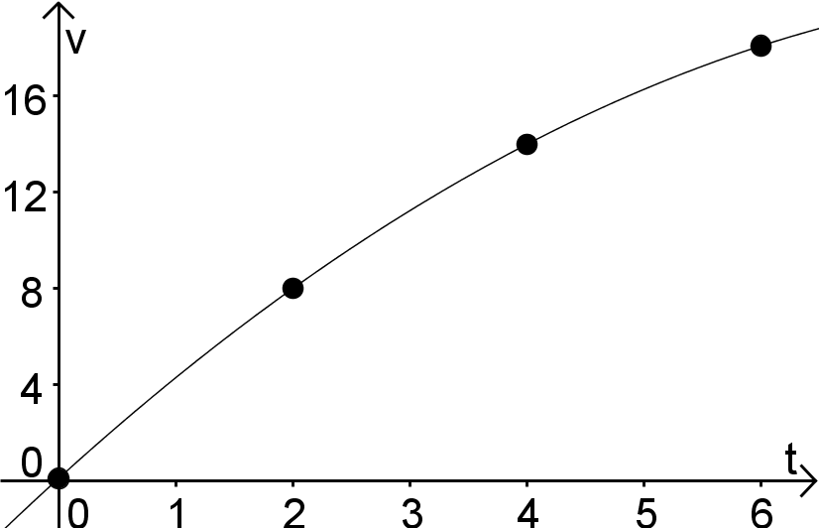

Visualization of Multiplication:

Distance Travelled from

$$t=4 to t=6$$

Distance Travelled from

$$t=2 to t=4$$

Distance Travelled from

$$t=0 to t=2$$

Example: Velocities (in ft/sec) of a runner starting a race are:

|  |  |  |  |  |
| --- | --- | --- | --- | --- |
| $t$**(sec)** | $$0$$ | $$2$$ | $$4$$ | $$6$$ |
| $v\left(t\right)$ (ft/s) | $$0$$ | $$8$$ | $$14$$ | $$18$$ |

How far did the runner travel from $t=0$ to $t=6$?

Underestimate: $0∙2+8∙2+14∙2=44$



Visualization of Multiplication:

Distance Travelled from

$$t=4 to t=6$$

Distance Travelled from

$$t=2 to t=4$$

Distance Travelled from

$$t=0 to t=2$$

Example: Velocities (in ft/sec) of a runner starting a race are:

|  |  |  |  |  |  |  |  |
| --- | --- | --- | --- | --- | --- | --- | --- |
| $t$**(sec)** | $$0$$ | $$1$$ | $$2$$ | $$3$$ | $$4$$ | $$5$$ | $$6$$ |
| $v\left(t\right)$ (ft/s) | $$0$$ | $$4.5$$ | $$8$$ | **11** | $$14$$ | $$16.5$$ | $$18$$ |

How far did the runner travel from $t=0$ to $t=6$?

Overestimate: $4.5∙1+8∙1+11∙1+14∙1+16.5∙1+18∙1=72$

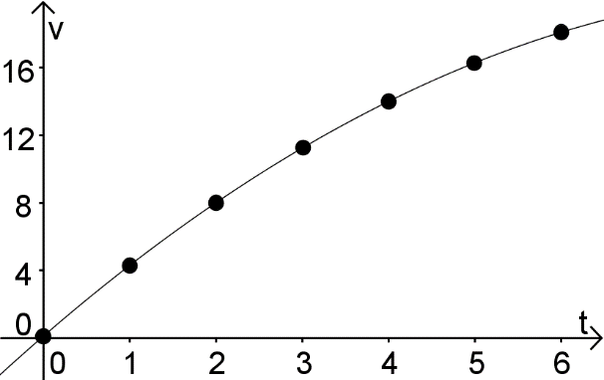

Visualization of Multiplication:

Dist Travelled from

$$t=1 to t=2$$

Dist Travelled from

$$t=2 to t=3$$

Dist Travelled from

$$t=3 to t=4$$

Dist Travelled from

$$t=4 to t=5$$

Dist Travelled from

$$t=5 to t=6$$

Dist Travelled from

$$t=0 to t=1$$

Example: Velocities (in ft/sec) of a runner starting a race are:

|  |  |  |  |  |  |  |  |
| --- | --- | --- | --- | --- | --- | --- | --- |
| $t$**(sec)** | $$0$$ | $$1$$ | $$2$$ | $$3$$ | $$4$$ | $$5$$ | $$6$$ |
| $v\left(t\right)$ (ft/s) | $$0$$ | $$4.5$$ | $$8$$ | **11** | $$14$$ | $$16.5$$ | $$18$$ |

How far did the runner travel from $t=0$ to $t=6$?

Underestimate: $0∙1+4.5∙1+8∙1+11∙1+14∙1+16.5∙1=54$



Visualization of Multiplication:

Dist Travelled from

$$t=1 to t=2$$

Dist Travelled from

$$t=2 to t=3$$

Dist Travelled from

$$t=3 to t=4$$

Dist Travelled from

$$t=4 to t=5$$

Dist Travelled from

$$t=5 to t=6$$

Dist Travelled from

$$t=0 to t=1$$

How far did the runner travel from $t=0$ to $t=6$?

Overestimate: The runner travelled at most $72$ feet in $6$ seconds.

Underestimate: The runner travelled at least $54$ feet in $6$ seconds.

How do we get a better estimate?

Notes from Graphs:

1.

2.

3.

$s\left(t\right)=position$; $v\left(t\right)=velocity$

$$v\left(t\right)=s'(t)$$

$$Distance Travelled$$

$$from t=0 to t=6$$

$$=$$

$$=$$

$$Distance Travelled$$

$$from t=a to t=b$$

$$Change of position$$

$$from t=a to t=b$$

$$=$$

$$Change of s(t)$$

$$from t=a to t=b=b$$

$$=$$

Example: Suppose that a car’s velocity, given is feet/sec, is:

$$v\left(t\right)=5t$$

How far does the car travel in the first 10 seconds?

Solution:

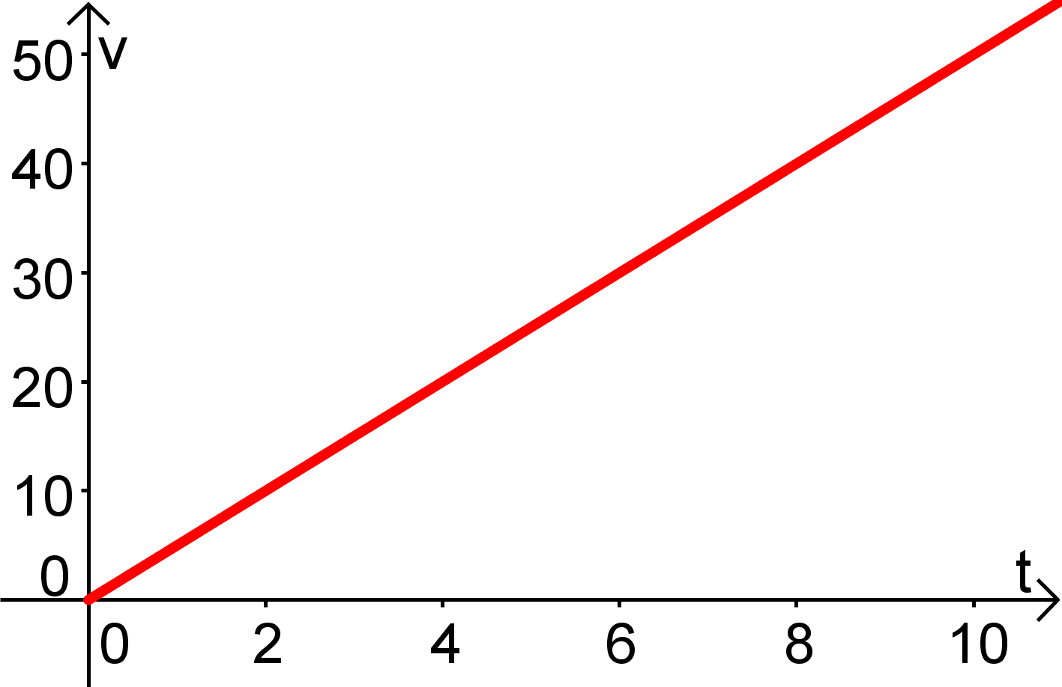

Conclusion:

Example 2: Suppose that a car’s velocity, given is feet/sec, is:

$$v\left(t\right)=5t+10$$

How far does the car travel in the first 10 seconds?

Solution:

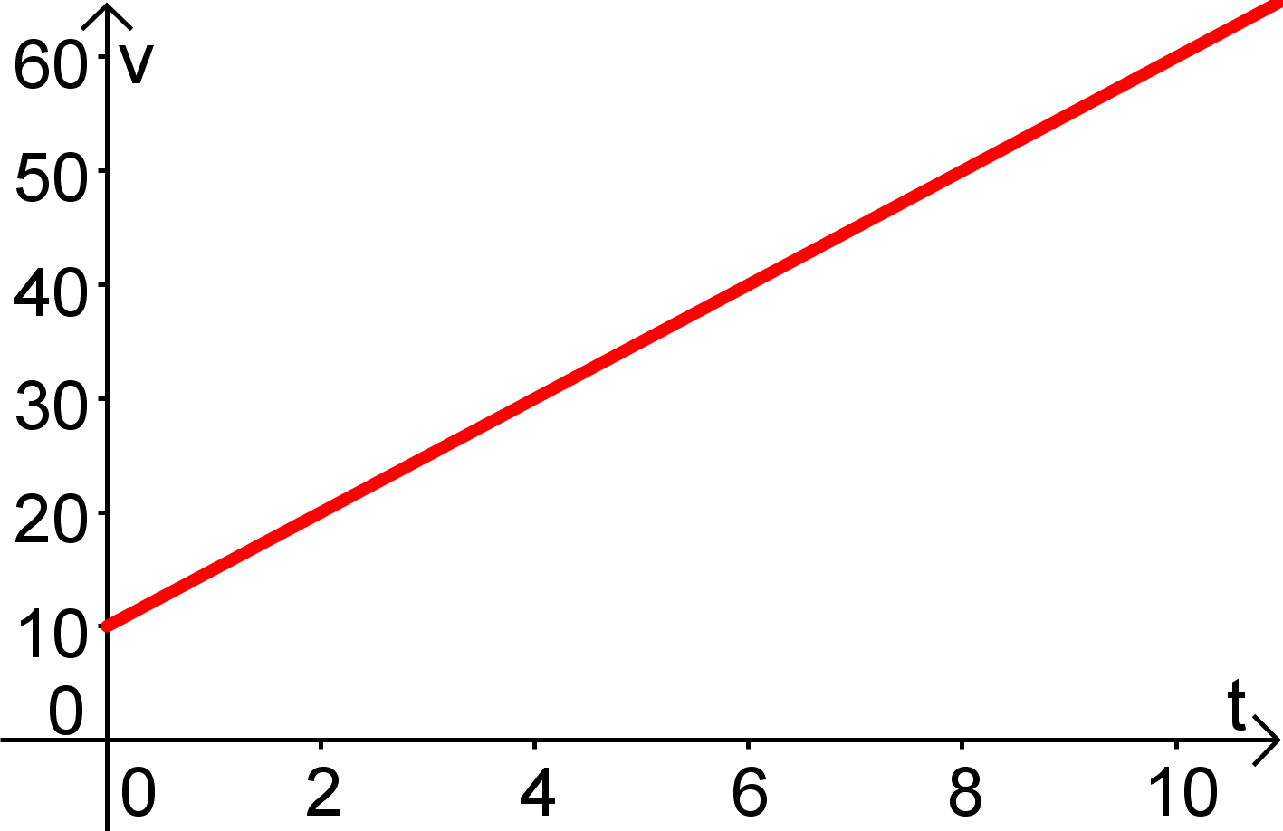

Conclusion: