Global Maxima and Minima

Definition: We say that $f\left(x\right)$ has a local minimum at $x=c$ if $f\left(c\right)$ is less than or equal to all other values of $f\left(x\right)$ near $c.$

Definition: We say that $f\left(x\right)$ has a local maximum at $x=c$ if $f\left(c\right)$ is greater than or equal to all other values of $f\left(x\right)$ near $c.$

Remark: We saw that for both the local maximum and minimum that $f^{'}\left(x\right)=0$. If $f^{'}\left(c\right)=0$ then $x=c$ is a critical pt.

Definition: We say that $f\left(x\right)$ has a at $x=c$ if

Definition: We say that $f\left(x\right)$ has a at $x=c$ if

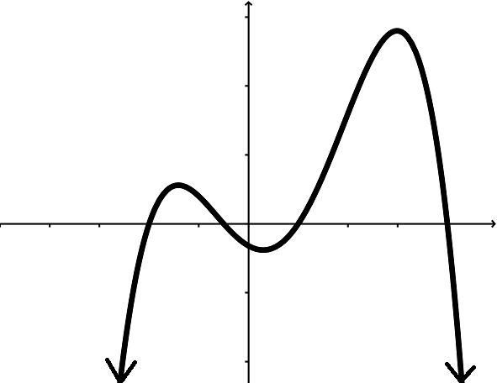

Extreme Value Theorem: If $f(x)$ is continuous on the closed, bounded interval $[a,b]$ then

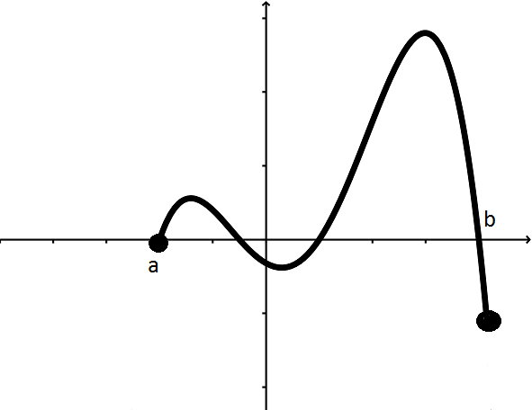

How do we find the global maximum and minimum?

Conclusion: The global max (or min) of $f(x)$ on $[a,b]$ is either at

Ex: Find the global max and min of $f\left(x\right)=x^{3}-9x^{2}+15x+6$ on the interval $[0,8]$.

Example 2: Find the global max and min of $f\left(x\right)=x^{3}-9x^{2}+15x+6$ on the interval $[0,4]$.