Local Maxima and Minima

Recall: We say that a function, $y=f\left(x\right)$, is increasing if

We say that a function, $y=f\left(x\right)$, is decreasing if

We say that a function, $y=f\left(x\right)$, is constant if

f(x) f ‘(x)

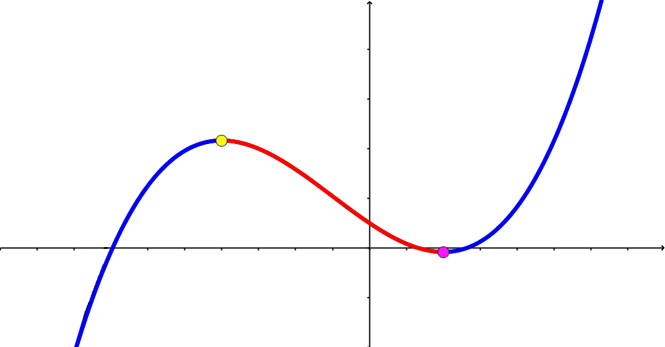 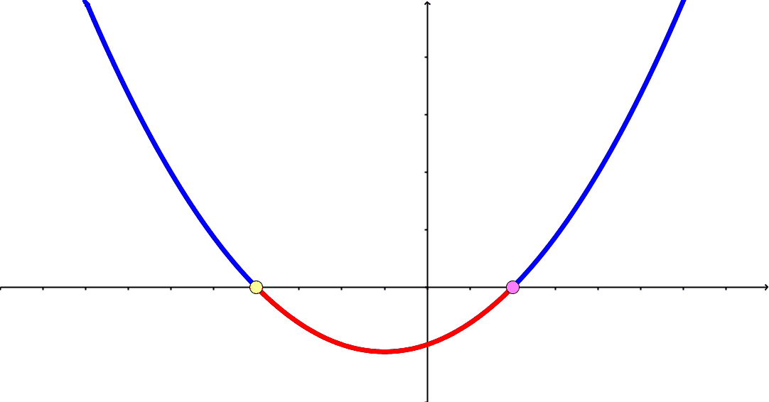

Definition: We say that $f\left(x\right)$ has a local minimum at $x=c$ if

Definition: We say that $f\left(x\right)$ has a local maximum at $x=c$ if

Definition: We say $f(x)$ has a critical point at $x=c$ if

First Derivative Test:

If $f^{'}\left(c\right)=0$ then:

$f(x)$ has a local max ; $f^{'}\left(x\right)=0$ and $f(x)$ is concave

$f(x)$ has a local min ; $f^{'}\left(x\right)=0$ and $f\left(x\right)$ is concave

Second Derivative Test:

If $f^{'}\left(c\right)=0$ then:

Example: Find all critical points of $f\left(x\right)=x^{3}+3x^{2}+24x-12$ and classify them as local max, local min, or neither.

Warning Ex: Find and classify all critical points of $f\left(x\right)=x^{3}$

